**Muna J. U**

gla data 1

**Assigment dATA VISUALIZATION**

Contents

Task 1 2

**Policies and Procedures** 2

Task 2 4

**Excel: GDP Sheet** 4

Set a password to protect my workbook. 4

Highlight column C and change the data to display in the British Pound symbol. 4

Turn the GDP sheet into a table, which I have illustrated how I did it. 5

Filter the table to display only the information for 2019. 5

Next create a chart that will only display the following data ‘Rank, Country and GDP - per capita (PPP). 6

**Using your creative skills edit the chart** 6

• Add a title 6

• Add X and Y axis labels 6

• Make the chart visually pleasing 6

Move the chart to a new sheet tab and label it with a suitable name. 7

Create a sort for the top 20 highest ranking countries 7

Next, create a new Bar chart to display the 20 highest ranking countries from your sort and then move the chart to be underneath the table. 8

The next task is to create 3 macro buttons, print the sheet, save the file and copy the sheet. 8

Using the copy macro, copy the sheet and then paste it into a new word document keeping the formatting. 9

Excel Gross domestic product report 1 9

To finish the excel table ‘Gross domestic product’ sheet, we will add a header and footer to our table. 9

Task 3 11

**Tableau** 11

# Task 1

## **Policies and Procedures**



This Act speaks majorly on the usage of the information gathered around people which is held on computers and the misuse of human rights. The data from ‘The Wealth of nations’ has been gathered from different countries and different data protection policies will have to be adhered. You have the right to know how your data will be used, have your data erased or stop the processing of your data.



The EU GDPR policy will play a part here considering the different country’s data in use.

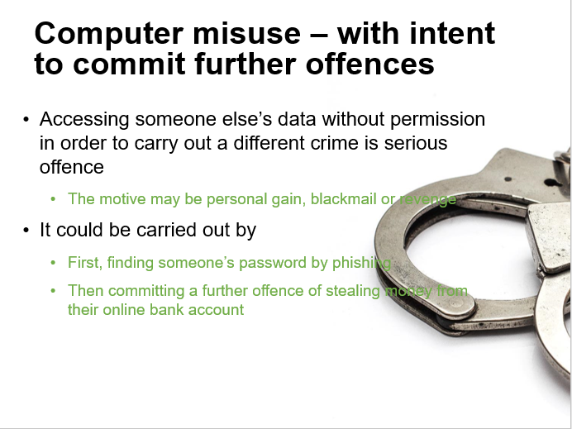

This Act protects personal data held by organisations from unauthorised access or modification of data without permission. The Act further makes a lot of things illegal which also includes hacking of computers or illegal access to computer materials.

# Task 2

## **Excel: GDP Sheet**

## Set a password to protect my workbook.

I have done this by going to protect the workbook, whereby creating a password and then confirming the password upon application.

## Highlight column C and change the data to display in the British Pound symbol.

I simply went to the home tab, clicked on general and then changed to the pounds symbol.

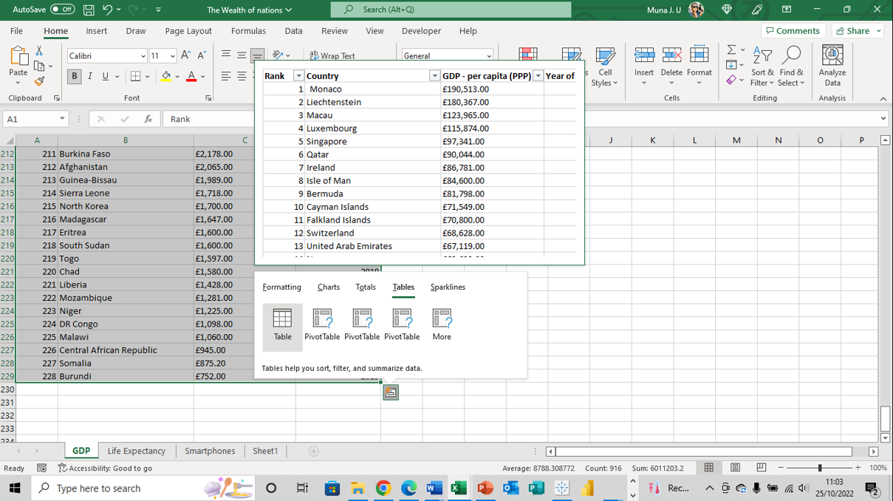

## Turn the GDP sheet into a table, which I have illustrated how I did it.

I have selected the basic table to aid me filter through the data.

## Filter the table to display only the information for 2019.

Did this by unselecting the year filter and choosing only 2019 then clicking ok to effect my changes.

## Next create a chart that will only display the following data ‘Rank, Country and GDP - per capita (PPP).

The chart can be anything as long as it is suitable. Below is my first preferred chart before my final choice.

## **Using your creative skills edit the chart**

## Add a title

## Add X and Y axis labels

## Make the chart visually pleasing

I have a chart above, went further to change the chart option. I filtered to my desired options and added a legend to the chart as well.

## Move the chart to a new sheet tab and label it with a suitable name.

I have depicted this chart as my final work done by changing my chart type as shown above.

## Create a sort for the top 20 highest ranking countries

I have done this by filtering column A (Rank) to select the numbers 1-20.

## Next, create a new Bar chart to display the 20 highest ranking countries from your sort and then move the chart to be underneath the table.

I have created a bar chart above to sort the 20 highest ranking countries, I did this by selecting my preferred chart from the insert tab and selecting the chart option. I also filtered my legends.

## The next task is to create 3 macro buttons, print the sheet, save the file and copy the sheet.

To copy the sheet in a macro, I started by recording my macro from the view tab. Also, highlighted the area to be copied then right-clicked copy and stop the macro. Next, I assigned the macro to the copy button.

## Using the copy macro, copy the sheet and then paste it into a new word document keeping the formatting.

Give the page the title ‘GDP (Gross domestic product)’ which I did on the word document.

## Excel Gross domestic product report 1

## To finish the excel table ‘Gross domestic product’ sheet, we will add a header and footer to our table.

Select the ‘View’ tab from the top and find the ‘workbook views’ area, as seen below:

* Select the ‘Page Layout’ icon. This will then display the screen with a header and footer as seen below. Note that there are three boxes for you to enter information into.
* In the header enter your name and GLA DATA 1 in the three boxes which I have done above.

* In the footer added today’s date then Assignment 1 and lastly Data Visualisation and I saved my table as ‘Excel Gross domestic product report 1’

# Task 3

## **Tableau**

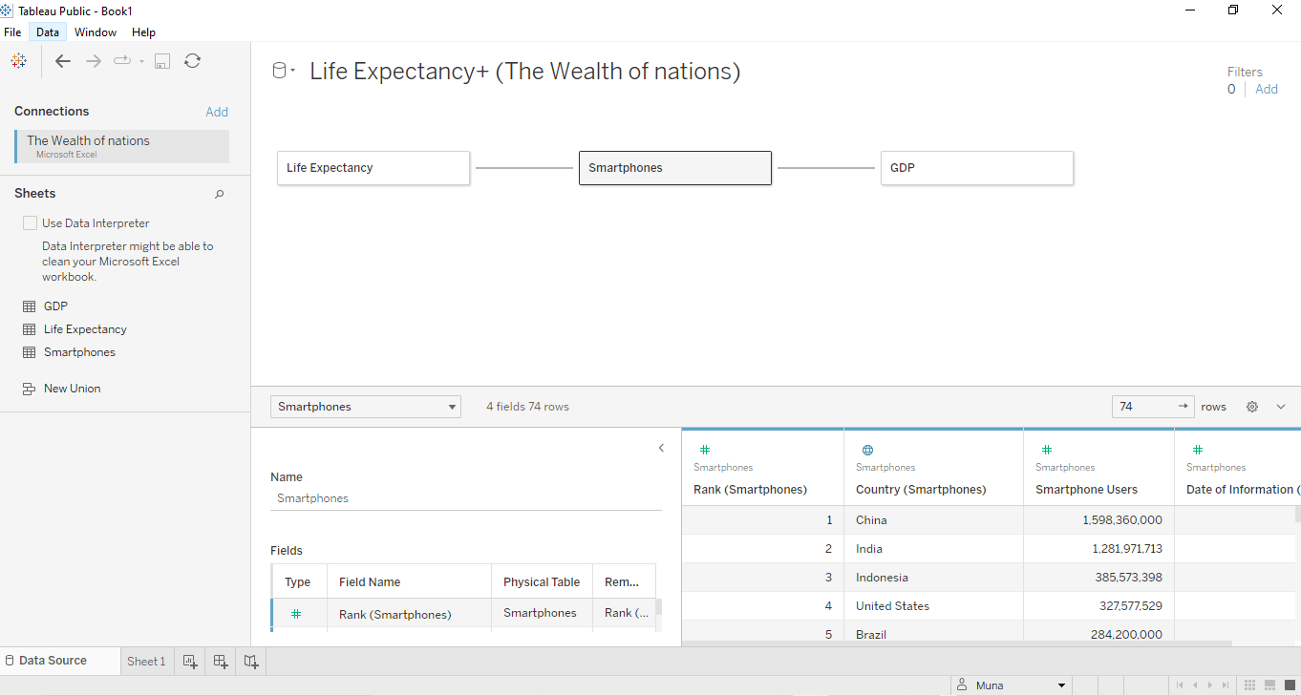

1. Import data
2. Set relationships:

I have three sheets and the common column for all of them is country, so the visual arrangement of the sheets does not matter. I have arranged the sheets in a straight line as shown above.

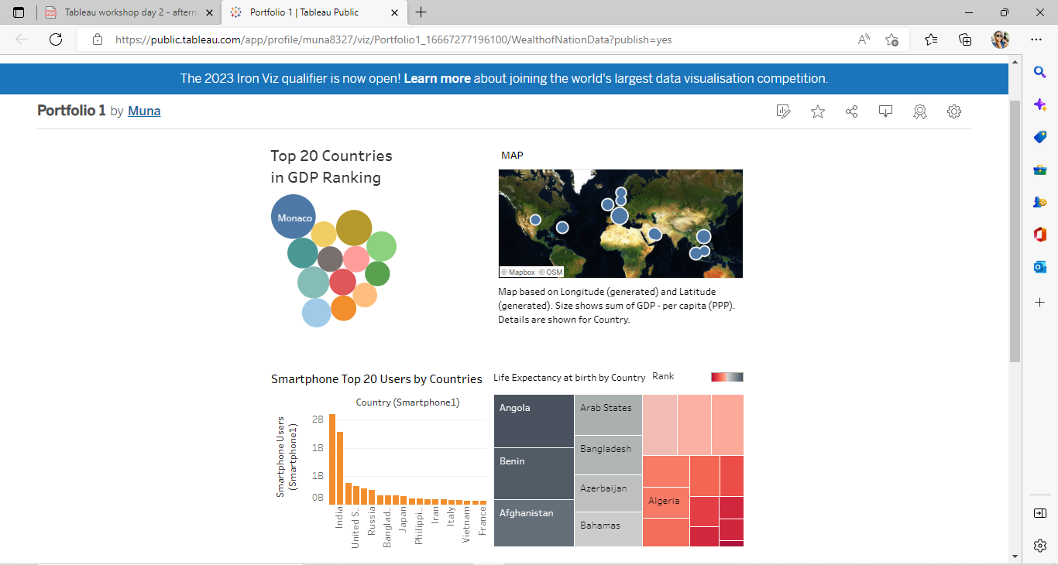

[Portfolio 1 | Tableau Public](https://public.tableau.com/app/profile/muna8327/viz/Portfolio1_16667277196100/WealthofNationData?publish=yes)